Module 8: CloudFormation Assignment -3
Problem Statement:
You work for XYZ Corporation. Your team is asked to deploy similar architecture multiple times for testing, development, and production purposes. Implement CloudFormation for the tasks assigned to you below.
Tasks To Be Performed:
1. Use the template from CloudFormation task 1.
2. Add Notification to the CloudFormation stack using SNS so that you get a notification via mail for every step of the stack creation process.
1. Create the SNS topic: cf-my-stack
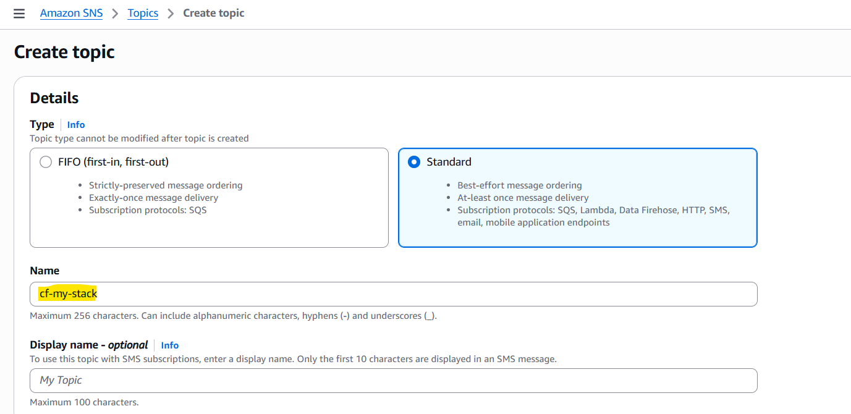
2. Add the subscription:
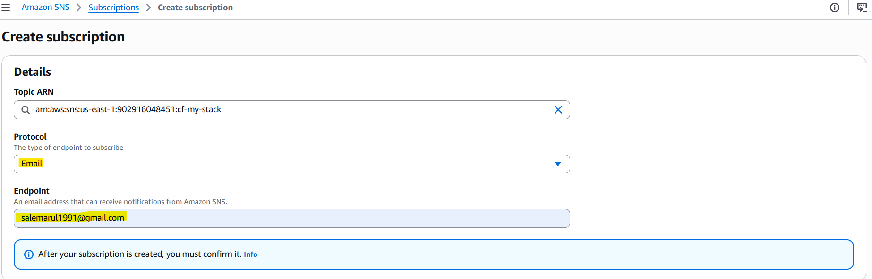

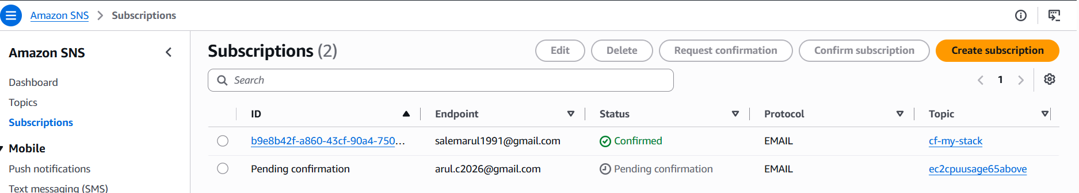
Create a JSON file for S3 bucket creation:
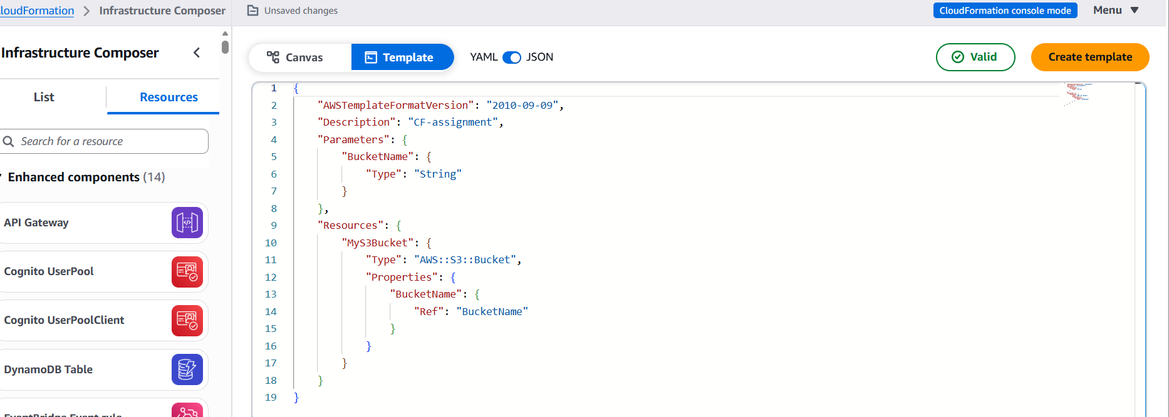

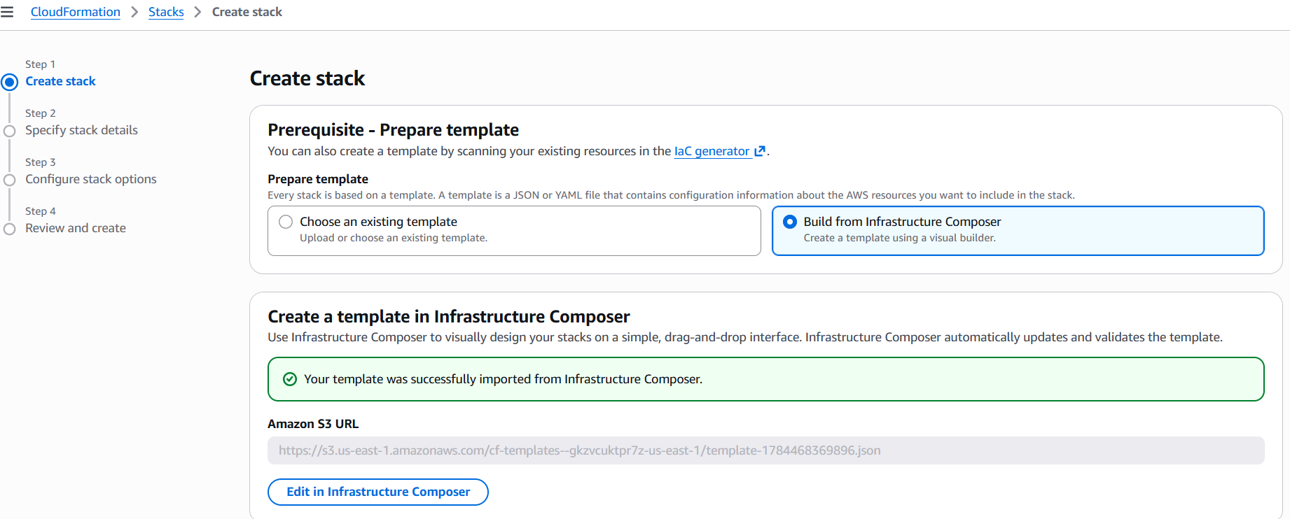
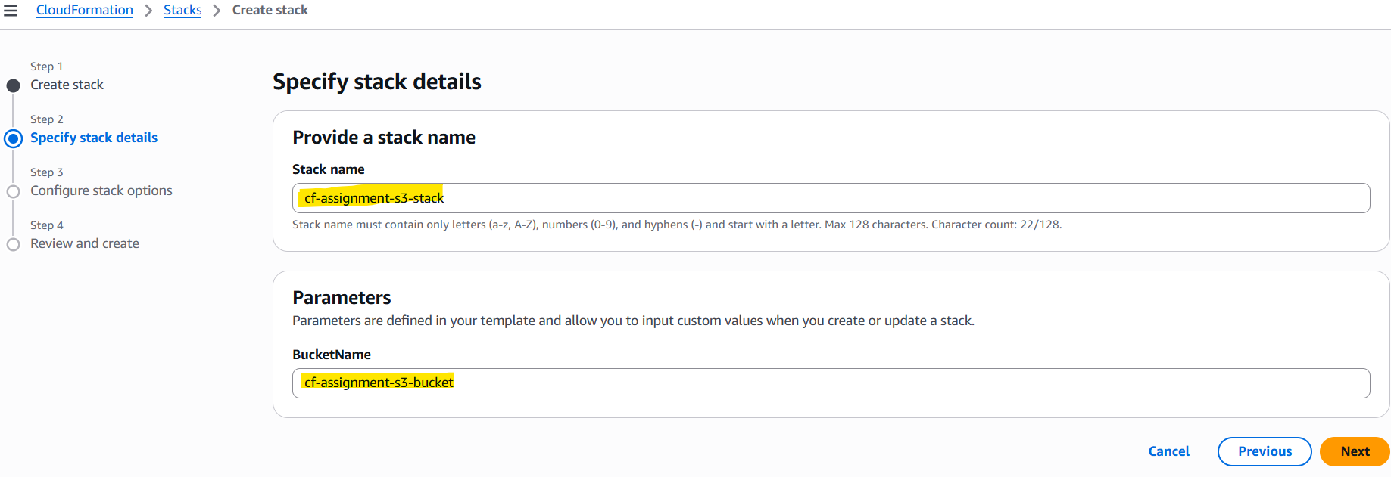
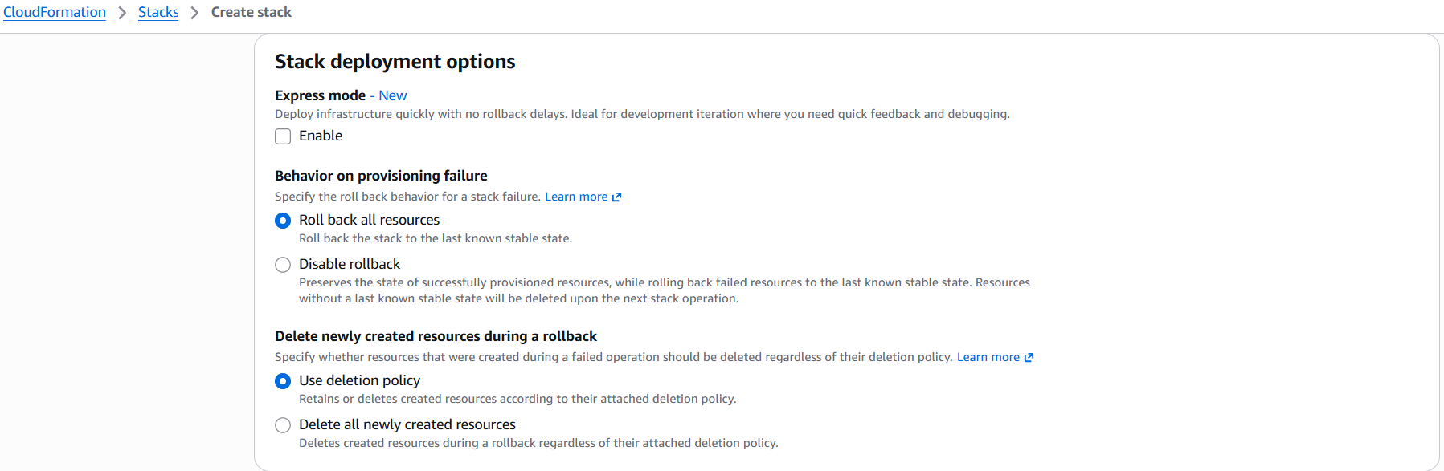
Add the existing SNS topic:
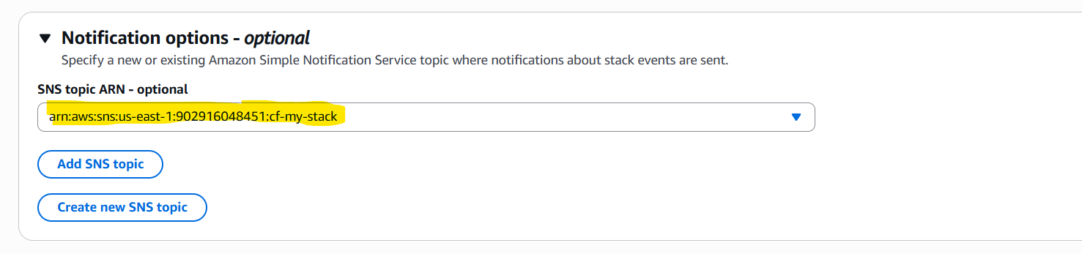
Executing the Stack:
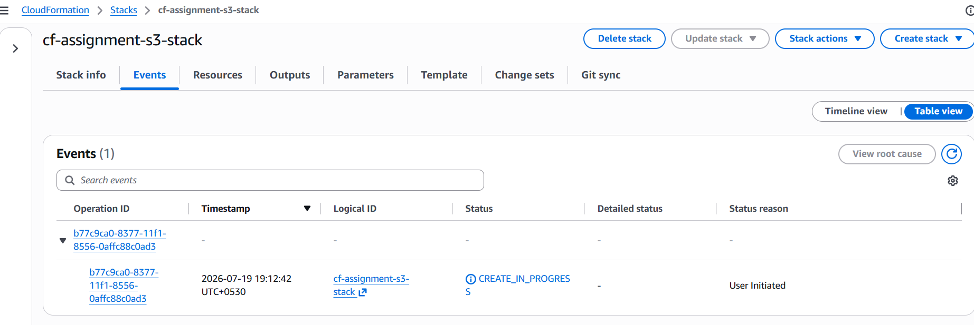
Confirmed the SNS notification:
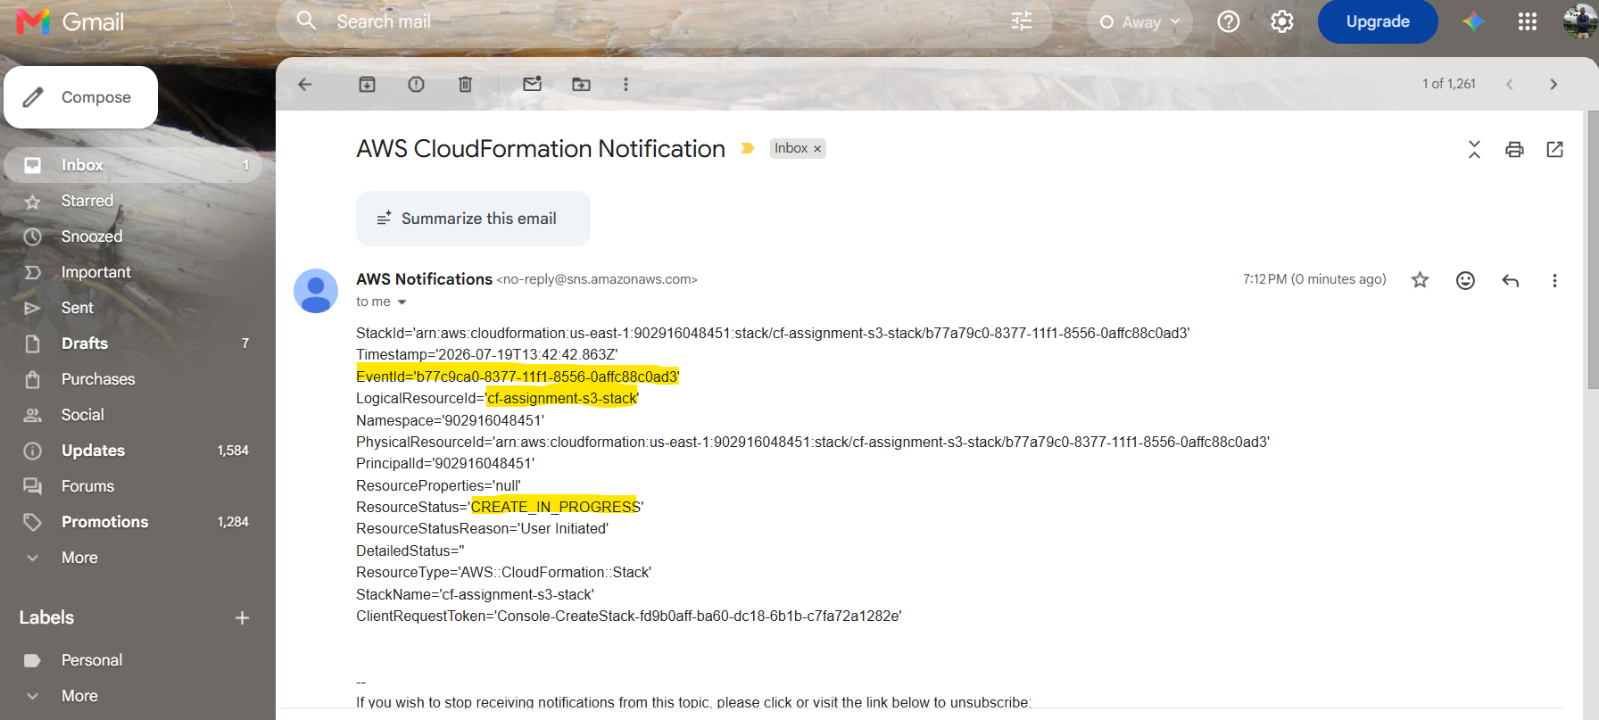
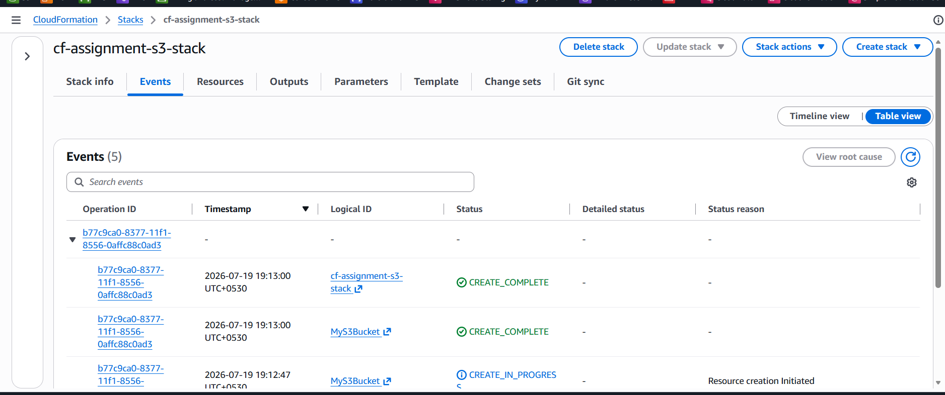
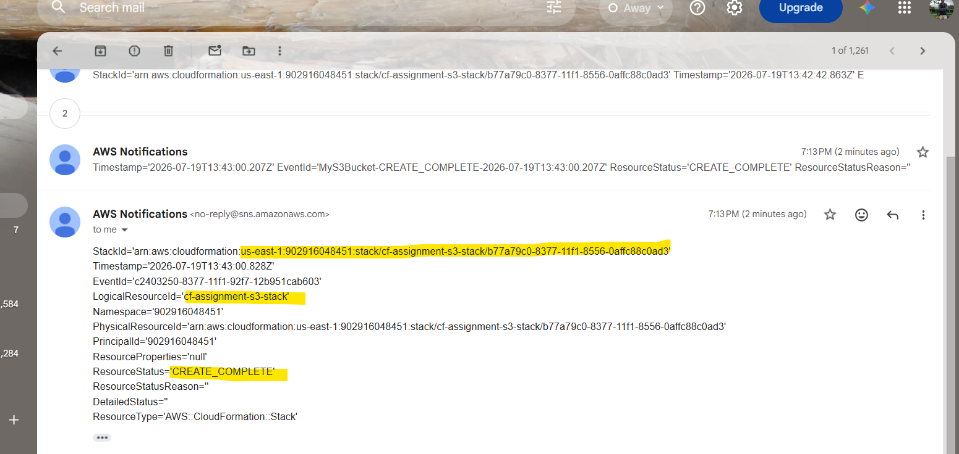
Verify the S3 bucket:
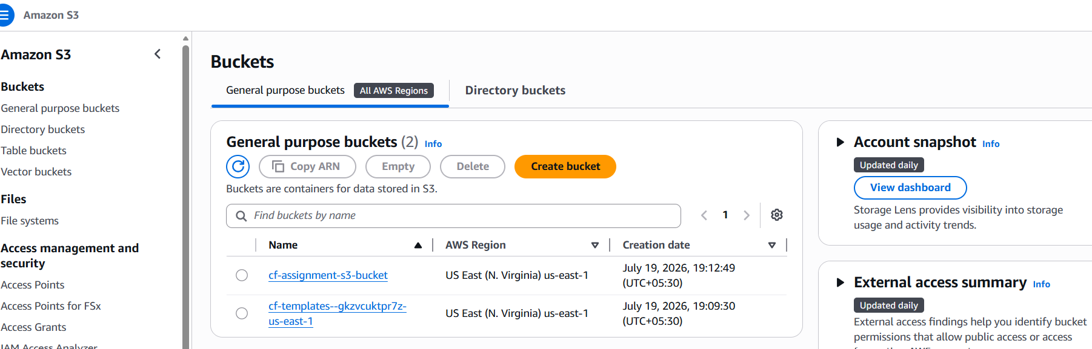
Deleting the Stack:
